210905212 psvaashish

week 5

sample1)

mapper.py:

import sys
for line in sys.stdin:
line = line.strip()
words = line.split()
for word in words:
print("%s\t\t%s" %(word, 1))

reducer.py:

from operator import itemgetter
import sys

current_word=None
current_count=0
word = None

for line in sys.stdin:
line = line.strip()
word,count=line.split('\t',1)
try:
count = int(count)
except ValueError:
continue
if current_word == word:
current_count += count
else:
if current_word:
print('%s\t%s' % (current_word, current_count) )
current_count = count
current_word = word
if current_word == word:
print('%s\t%s' % (current_word, current_count))

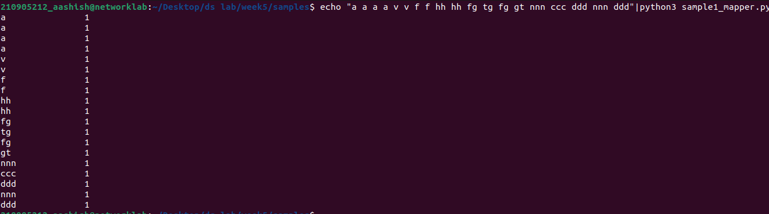

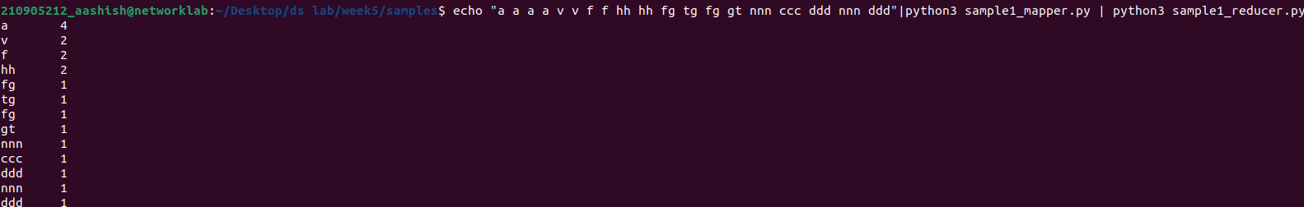
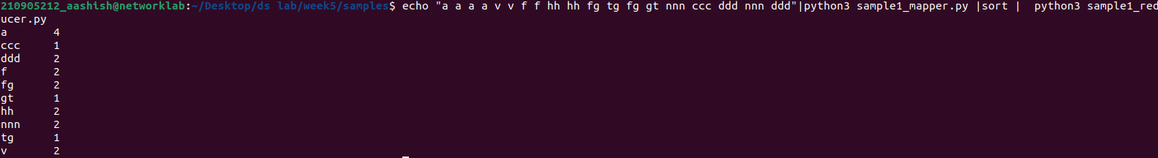
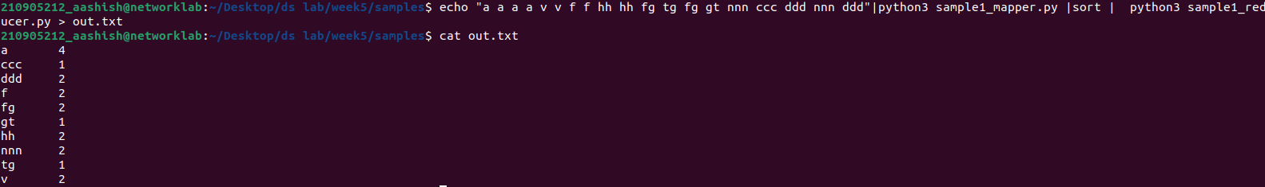
q2)
freqmap:
from __future__ import print_function
import sys

for line in sys.stdin:
L = [ (word.strip().lower(), 1 ) for word in line.strip().split() ]
for word, n in L:
print( '%s\t%d' % (word, n) )
frered1:
#!/usr/bin/env python
# reducer.py
from __future__ import print_function
import sys
lastWord = None
sum = 0
for line in sys.stdin:
word, count = line.strip().split('\t', 1)
count = int(count)
if lastWord==None:
lastWord = word
sum = count
continue
if word==lastWord:
sum += count
else:
print( "%s\t%d" % ( lastWord, sum ) )
sum = count
lastWord = word
# output last word
if lastWord == word:
print( '%s\t%s' % (lastWord, sum ) )
q2.2)
map2:
from __future__ import print_function
import sys
# input comes from STDIN (standard input)
for line in sys.stdin:
word, count = line.strip().split('\t', 1)
count = int(count)
print( '%d\t%s' % (count, word) )
red2:
from __future__ import print_function
import sys
mostFreq = []
currentMax = -1
for line in sys.stdin:
count, word = line.strip().split('\t', 1)
count = int(count)
if count > currentMax:
currentMax = count
mostFreq = [ word ]
elif count == currentMax:
mostFreq.append( word )
# output mostFreq word(s)
for word in mostFreq:
print( '%s\t%s' % ( word, currentMax ) )
q3)
map:
#for example.txt
import fileinput
for line in fileinput.input():
data = line.strip().split("\t")
if len(data) == 6:
date, time, location, item, cost, payment = data
print ("{0}\t{1}".format(location, cost))
red:
#for example.txt
import fileinput
transactions_count = 0
sales_total = 0
for line in fileinput.input():
data = line.strip().split("\t")
if len(data) != 2:
# Something has gone wrong. Skip this line.
continue
current_key, current_value = data
transactions_count += 1

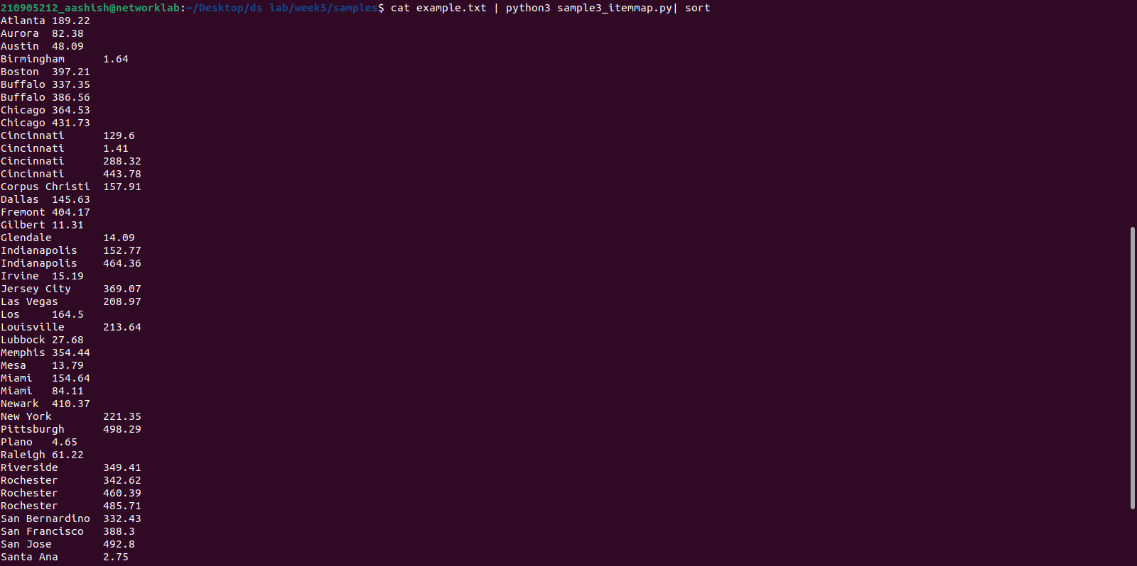
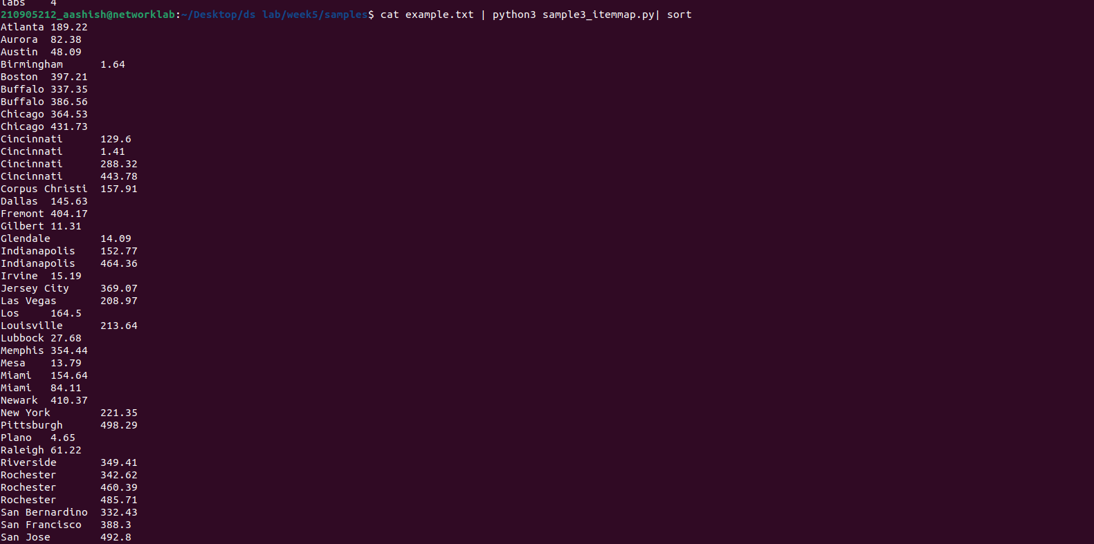
sales_total += float(current_value)
print (transactions_count, "\t", sales_total)

